2021 Program Information

Thanks for your interest in planting trees in your neighborhood! Please fill out the information below to the best of your ability to request a tree(s) through the Grit City Trees program. The goal of this program is to assist historically underserved neighborhoods to increase tree cover in their rights-of-way (the space between the edge of your property and the street) by providing free street trees. Through this program, we want to ensure the right tree in the right place. For tree planting see our proper tree placement webpage. Additionally, we will provide supporting materials to help your trees to thrive including tree stakes, ties, TAGRO, and watering supplies for the dry months.

Contact the City of Tacoma Urban Forestry at trees@cityoftacoma.org or (253) 502-2138 for submittal or assistance. Please contact us prior to the application deadline, to provide enough time to address any issues. Tacoma Urban Forestry will hold “office hours” for application assistance. Email to set up a meeting or call the above number Tuesdays through Thursdays 10am-12PM.

Timeline
Aug - Sept 2021: Completed individual applications are due August 22. Completed group applications are due September 5. Depending on availability, we may be able to distribute a second round of Grit City Trees for applications submitted past this date.
September 2021: The City of Tacoma reviews applications. Confirmations are sent to residents with tree distribution details. Due to limited resources for the 2021 program year, trees will be distributed on a first-come first-serve basis. If we are unable to provide you with a tree this year, be sure to reapply for the 2022 Grit City Trees Program or consider applying to our Tree Coupon Program.
Oct- Nov 2021: Grit City Trees Delivery to Neighborhood groups from the second to third week in October and Individual Pick-up will be scheduled for the last week in October through early November.
November 2021: Trees will be available at the City of Tacoma tree nursery for pick-up by individual applicants to be planted in their right-of-way. Tree delivery to neighborhood groups is available courtesy of Washington Conservation Corps. *If you need planting assistance, the Pierce Conservation District can, on a case-by-case basis, offer delivery and planting help to participants who need physical assistance or lack access to a vehicle.* Select planting assistance on page 5.
May 2022: Washington Conservation Corps crews will deliver watering supplies to neighborhood groups while Urban Forestry Staff will distribute watering supplies to individual applicant’s trees.

Options for Receiving FREE Trees for your Right-of-Way (street trees)

Neighborhood Group Applications (Neighbors Planting Together):
Neighbors who organize a tree planting that involves a minimum of three participating households within a two-block distance (with a target of 10 or more trees) will qualify to submit a Neighborhood Group Application.
- Each individual property owner needs to submit a signed “Tree Care Agreement, Including Liability Release” form included in this packet and call for a utility locate (dial 811) to ensure there is enough planting space for new trees.
  - Please submit neighborhood applications together as a packet.
  - Successful Neighborhood Group Applications will have trees delivered by City of Tacoma to one designated drop-off address.
- Neighborhood applications are preferred and will receive free delivery of all trees and supporting material.
Individual Request Applications:

- For individuals interested in free trees for their right-of-way, an individual property owner must submit an application along with the “Tree Care Agreement, Including Liability Release” form included in this packet and call for a utility locate (dial 811) to ensure there is enough planting space for new trees.
- Please note, there is a limited availability of trees and preference is given to group applications and those in priority locations (refer to Planting Priority Areas map).
- Successful individual applications will be required to pick up trees from the City of Tacoma Plant Holding Facility at the Recycling and Transfer Center. Confirmation regarding dates for pick-up will be sent out at least two weeks before pick-up days.
Submission:
Completed applications may be submitted by email to trees@cityoftacoma.org or send a hard copy by mail to 326 East D St., Tacoma, WA 98421 (Attn: Urban Forestry). If you are unable to submit digitally or by mail, please call (253) 442-5874 to arrange alternate options for submission.

Planting Day Necessities & Suggestions:
- Call 811 or 1-800-424-5555 (www.callbeforeyoudig.org) to locate underground utilities. It is required by law according to the Underground Utilities Damage Prevention Act to call for utility locations to be marked at each planting location before you dig.
  - For Neighborhood Group Applications, confirm that neighbors can pick-up their trees from the designated house and that everyone called 8-1-1 to have underground utilities marked.

- Tools to plant a tree:
  - Shovels
  - Gloves
  - Tarp to hold soil and turf during planting
- Water source, hose, buckets
    - Consider contacting Tacoma Tool Library if you need equipment to plant your tree.

- Review Proper Planting Practices at the City of Tacoma Urban Forestry Website.
  - Proper planting is crucial to the survival of your new tree
  - Dig a hole approximately 2’ deep and twice as wide as the root ball
  - Plant only as deep as the trunk flare

- Soil in the planting strip is frequently rocky and compacted. Amending the existing soil can mean the difference between your tree(s) surviving or not. A great option to amend the soil is to mix TAGRO with the native soil. We can provide one bag of TAGRO per tree but loose TAGRO is available at the main TAGRO pickup location is at the Central Treatment Plant off Portland Avenue. For more information about TAGRO, please visit www.cityoftacoma.org/tagro or call (253) 502-2150.

- The City of Tacoma Urban Forestry Program will coordinate delivery of trees for Neighborhood Groups with the Washington Conservation Corps, but are unable to plant the trees. Residents and neighbors are encouraged to try to work together to plant and care for their Grit City Trees.

Other Important Considerations:
Trees provided through the Grit City Trees Program must be planted in the right-of-way only. The space between the edge of the road and the edge of your property line. To see the extent of your right-of-way, check out Tacoma’s DART map. Search for your address in the top left corner of the screen. I find it helpful to turn on a satellite image by clicking the four squares in the top right to select a new basemap. This lets you reference features on a property and shows where your property boundary and right-of-way are.

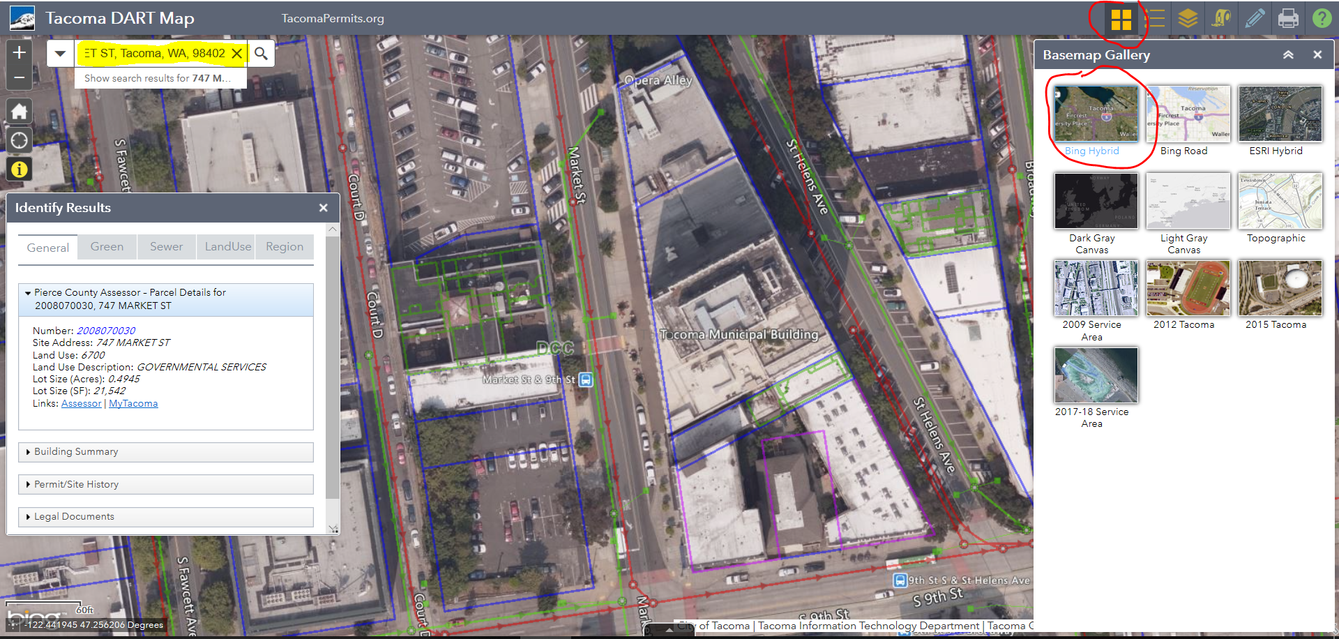

In accordance with Tacoma Municipal Code Chapter 9.17, 9.18, and 9.19, abutting property owners are allowed to landscape the planting strip and are responsible for the maintenance of the planting strip, unless otherwise specified by the City. Additionally, the full width of the sidewalk must be clear of vegetation to a height of 8 feet, so pedestrians can walk safely. The full width of the street must be clear of vegetation to a height of 14 feet, so emergency vehicles and delivery trucks have safe access.
Application for Grit City Trees

Contact Name: Email:
Daytime Phone: Alternate Phone:
Alternate Contact: Email:
Daytime Phone: Alternate Phone:
Planting Address: __________________________________________________
Number of trees requested for this address: ____________
Are there power lines or other overhead wires above the planting site? (Y/N) __________
What is the width of the planting area (planting strip): ____________
Utility locate number/ticket number: ______________________
Are you renting? (Y/N) _____ . If yes, thank you for considering the Grit City Trees Program. Please ensure property owner is aware of and signs the Tree Care Agreement on the last page.
To help us build a more robust program for future years, please tell us how you heard about Grit City Trees:
_________________________________________________________________________________________________
Check here if you require planting assistance. Due to staffing constraints, this is available at a limited capacity.
Check here if you would like to talk with Tacoma Tree Foundation about getting additional trees for your block.

Required For Neighborhood Group Applications:

Contact name and phone number for Delivery: _________________________________________________

Address for delivery of trees and supporting materials: __________________________________________

Additional information about delivery location (e.g. Drop off everything in the driveway):

________________________________________________________________________________________
Designated drop-off house is willing to be a pick-up site for neighbors not included in the group application? (The City of Tacoma will contact you ahead of time with more information): (Y/N) _________

Request your tree(s):
Please write in your preferred tree type and if you are interested or would accept evergreen trees below.
Tree availability from wholesale growers is scarce in 2021 due to the COVID-19 pandemic. We will do our best to find a tree that will suit your needs, but cannot guarantee specific species at this time. You will not be required to accept a non-preferred tree.
Urban Forestry Staff will contact the email provided above with a set availability list by August 2021. Please respond to this email with your top three choices for trees including quantities.
The full list of species will be available at cityoftacoma.org/gritcitytrees by August 2021.
Tree Types:
Large: Planting strip 8’ or wider - Shade Tree taller than 25’ at maturity
Medium: Planting strip 5’-8’ wide - Shade Tree taller than 25’ at maturity
Suggested spacing between trees: 30’ from the center of the trunk.
Shade trees maximize benefits to your neighborhood. It’s important to plant them any time we have the space available. We encourage you to select a shade tree option if you have a planting strip over 5’ wide and no overhead utilities.
Small Trees - for under power lines, 15’-25’ at maturity
Suggested spacing between trees: 20’ from the center of the trunk.
Small trees are available for sites with overhead utilities (power lines) or narrow (3’-5’) foot wide planting strips.

Requested Quantity of Trees  (Ex: 3) | Tree type (Small, Medium, or Large Tree)

= please mark if you are interested in or would accept evergreen trees for your ROW
Tree Planting Map
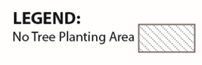
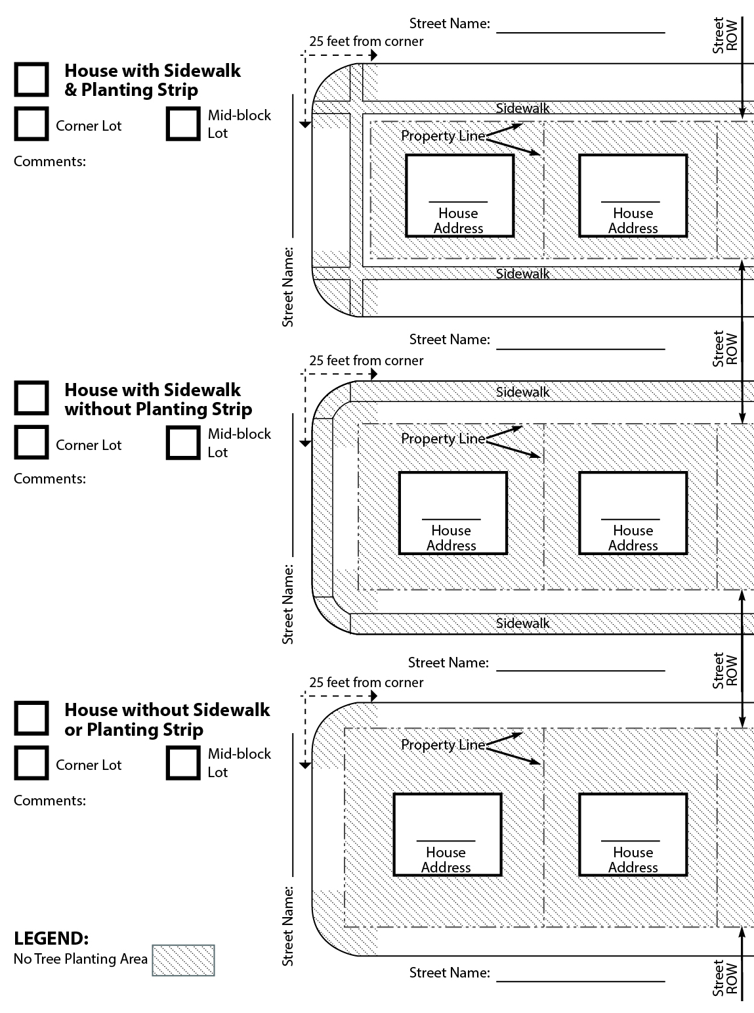
Indicate on the map which location best fits your house, and mark the locations where you intend to plant the tree(s).

TREE CARE AGREEMENT, INCLUDING LIABILITY RELEASE
City of Tacoma Street Tree Program

The undersigned ("Property Owner") wishes to participate in the City of Tacoma’s (City) Street Tree Program. In consideration for receiving a free street tree and consultation services from the City’s Urban Forester, Property Owner hereby agrees:

- To forever release, discharge and hold City, together with its officers, directors, agents, employees, representatives, and affiliates, and each and all of their respective successors and assigns (collectively, the "Released Parties ") free and harmless from any and all debts, claims, demands, damages, actions, causes of action, liabilities, losses, judgments, costs and expenses for any reason arising out of or in any way connected to Property Owner's receipt and planting of a street tree at (address) including but not limited to injury or damage incurred by Property Owner or a third party, or to Property Owner's property, in connection with any tree(s) received and planted;

- To covenant not to sue or otherwise bring any legal action against each and all of the Released Parties for or on account of any claim associated with the street tree;

- To indemnify, hold harmless and defend each and all of the Released Parties from and against any and all claims arising out of the receipt of the street tree(s) or the planting of the street tree(s), excepting those claims caused by the sole active negligence or willful misconduct of the Released Parties;

- To maintain the street tree(s), including roots, trunks, branches and leaves, so that no part of the tree(s) causes or contributes to sidewalk defects or other hazardous conditions in the right of way.

- To not top, stub cut, or otherwise prune the tree trunk and/or branches in such a manner as to permanently damage the structure of the tree, unless doing so is to specifically address potential hazardous conditions.

I HAVE READ THE FOREGOING RELEASE AND INDEMNITY IN FULL AND
VOLUNTARILY CONSENT TO ITS PROVISIONS.

Signed on: ______________________(Date) ________________________________(Location)

Property Owner’s signature:

Property Owner’s printed name:
Property Owner’s Mailing Address (if different from street tree planting location): _____________________________________________________________________________________

Address of street tree planting location:
_______________________________________________

Pre-Submission Checklist

_____ Tree Care Agreement and Liability Release signed and submitted by all property owners (pg. 8).

_____ Neighborhood Group Applications:

_____Have at least three applications signed by property owners been included?
_____Have you identified a single drop-off address for the trees and supporting materials?

_____ I have read about tree placement in the right-of-way at the “Planting in the Right-of-Way” webpage. Check the extent of your right of way at Tacoma’s DART map

_____ I have marked the locations for my new tree(s) on the attached map (pg. 7)

_____ I have provided a utility locate ticket number for this property by calling 811 (pg. 5) WA State requires by law that you call no less than 2 days before you dig.

Additional information or comments:

