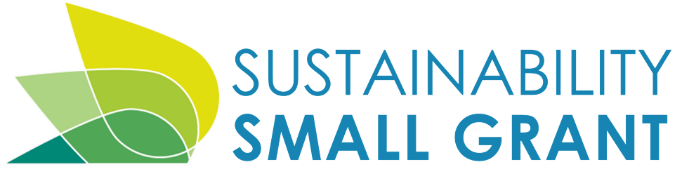
Earth Day 2020 – Artist Application

The City of Tacoma’s Office of Environmental Policy and Sustainability (OEPS) is seeking artists interested in creating environmentally-inspired art and projects to celebrate the 50th Anniversary of Earth Day on April 22, 2020.
Through the Sustainability Small Grant Program, reimbursable awards of up to $5,000 are available to individuals or groups interested in creating art that express our global concern for environmental issues. Examples may include: proposals for public art installations, public dance performances, art programs for local youth, etc. Priority consideration will be given to proposals with an emphasis on the importance and value of trees and our urban forest.

Pieces must be complete or scheduled by March 31, 2020 in order to be featured as part of the City’s Earth Day celebrations, but may also be displayed and promoted throughout 2020.

Please fill out the application and submit via email to sustainability@cityoftacoma.org.

If you have questions, please contact the City of Tacoma Office of Environmental Policy and Sustainability at
(253) 591-5172 or sustainability@cityoftacoma.org.

Contact Information

Applicant Name: Date:

Organization (N/A if individual):

Brief description of organization (N/A if individual):

Mailing Address:
Please use an address where you can receive and respond to mailed materials in a timely manner, including during summer months.

Phone Number (day): E-mail Address:

Project Scope Information

Project name: Monetary Amount Requested:

- Brief Project Description (50 words max):

- Scope Summary: (Please include who is doing the project, what the project involves, planned outcomes and rationale.)

Further explanation, details or elaboration on your project:

- Project or event proposed location/street address (if applicable):

- Does your project or event require legal access permission (located on private land)?
Yes
- No
If access is required, attach a copy of a permission letter from the property owner.

Does your project address any of these three aspects of sustainability in our community? Please explain.
7a) Economic

7b) Equity & diversity (i.e. race, gender, age, disability, etc.)

7c) Culture (in addition to art: recreation, historic preservation, etc.)

- If applicable, how does your project benefit Environmental Services’ three utilities (Surface Water, Solid Waste, and Wastewater)? (See the online FAQ for information about these utilities) Please check all that apply and describe below.
*cannot receive funding for Surface Water activities if project also receives Make A Splash grant
Surface Water: Solid Waste: Wastewater:

How will your project help the City of Tacoma celebrate Earth Day 2020?

- Have you coordinated efforts with other agencies/partners/principals/stakeholders? Please list partners and explain. If support is necessary to complete your project, you must include a letter or email from them describing their support.

- Does this project leverage other funds or services? Please explain.

- If holding an event, does the event meet the criteria for mandatory participation in the City’s Green Event Program?
Yes No
*If Green Event Program participation is required, attach a copy of the application.

How will this project help engage with or educate community members about environmental or sustainably related issues?

- Does your project have an ongoing benefit and/or maintenance requirement that will continue once funding has ended? Please explain.

- Are you aware of a similar project that has been implemented elsewhere? If so, please briefly describe.

- How did you hear about the Sustainability Grant program?

- List the specific activities or steps needed to complete your project, from first to last.
Part C: Project Timeline and Estimated Budget
- List costs, including necessary equipment, supplies, labor or other expenses. Up to 10 percent of the grant may be spent on food, and up to 20 percent can be spent on overhead or general administrative costs. The grant cannot fund computers, digital cameras, video cameras or other portable electronic equipment (may be waived at the discretion of the Office of Environmental Policy and Sustainability). A disposable camera and film development may be included in the grant budget. If the designated grant recipient charges an administrative fee, or others are hired to perform work, you may include those fees in the budget.

BRIEF DESCRIPTION OF EACH ACTIVITY | START DATE | END DATE | COST, IF ANY | BRIEF DESCRIPTION OF COSTS |  | MATCHING CONTRIBUTION? YES/NO*
Example: Produce banner promoting garden  plot availability | 11/1 | 12/1 | $200.00 | 3 x 12 ft. banner – 1 color. |  | No
Final Project Completion:
GRAND PROJECT TOTAL: |  |  | $ 0.00

Note: Although the reimbursement costs assigned to each item/activity may vary from this budget estimate, items not listed on this approved budget will not be reimbursed.

*10% of total project costs must consist of a matching contribution from the applicant. Matched contributions may include in-kind or funds from your organization or any other grants, sponsors, donations, volunteers (example value: $25/hr), etc. Complete the table below to reflect the Project Total Amount and the Total Match Amount.

 | Dollar Amount
Total Request Amount | $
Total Match Amount (10% of Grand Project Total Amount) | $
Grand Project Total | $ 0

Supplemental Information:
- If your grant application is approved, the following items (if they apply) must be obtained before beginning your project and prior to receiving any grant funds, but they are not required to be submitted with your application.
Permits: If your grant application is accepted and your project requires a permit (building permit, wetland development permit, or any other type of permit from the City of Tacoma or other governmental agency), you will need to obtain those permits before beginning your project and prior to receiving any grant funds.
Public agency approval: If your project is located on public land (for example, Metro Parks property, Tribal property, School District property, right of way, etc.), you will need to obtain public agency approval and a permission letter from the appropriate agency before beginning your project and prior to receiving any grant funds.

- The individual items and activities listed in the budget under grant application Part C may be reimbursed as each activity is completed. Please submit an invoice form (an example is available on the grant website) with receipts attached to request partial reimbursement. The entire grant amount will not be reimbursed until the project is complete and a final report is submitted and approved. Final report guidelines are available on the grant website.

NOTE: Please document the project with photographs and turn in with your request for reimbursement. If you use a digital camera, burn a CD with high-resolution images for use in future City publications or promotional materials.

Applicant Signature: Date:

Date:
_
Amount:
Official use only

Approved Signature: Comments:

