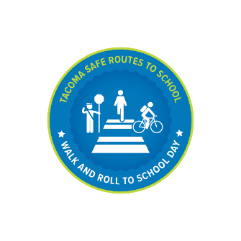

**Walk or roll to school with your friends and neighbors!**

**On <ENTER DATE>, <SCHOOL NAME> is participating in   
Walk and Roll to School Day**

**October is National Walk and Roll to School Month when schools   
around the country celebrate walking and rolling to school.**

**About our event:**

**Contact <name of organizer> at <email or phone> if you would like more information about the event.**



**Walk or roll to school with your friends and neighbors!**

**On <ENTER DATE>, <SCHOOL NAME> is participating in   
Walk and Roll to School Day**

**October is National Walk and Roll to School Month when schools   
around the country celebrate walking and rolling to school.**

**About our event:**

**Contact <name of organizer> at <email or phone> if you would like more information about the event.**