Team Number:

WWHM Model Inputs

Site Land Use Summary Table Site Hydrology Summary Table
Predeveloped | Acres | Mitigated | Acres |  | Return Interval | Predeveloped Flow (cfs) | Mitigated (cfs)

Facility Design Element Parameters
  - NOTE: Please provide a summary table for each element proposed or provide WWHM screenshots for the Elements. Example: Porous Pavement Element

Element Table

Contributing Area (acres) |  | Ponding Depth Above Pavement (ft)
Pavement Length (ft) |  | Effective Volume Factor
Pavement Bottom Width (ft) |  | Underdrain Diameter (in)
Bottom Slope (ft/ft) |  | Underdrain Height (ft)
Pavement Thickness (ft) |  | Infiltration
Pavement Porosity (0-1) |  | Measured Infiltration Rate (in/hr)
Sublayer 1 Thickness (ft) |  | Reduction Factor (inf fact)
Sublayer 1 Porosity (0-1) |  | Use Wetted Surface Area
Sublayer 2 Thickness (ft)
Sublayer 2 Porosity (0-1)

WWHM Screenshots (insert below)

Infiltration Summary

Infiltration Rate Used and Why:

Depth to Groundwater or Impermeable Layer:

Site Characterization Criteria:

South Tacoma Groundwater Protection District
Site 1 – South Tacoma Way and Site 2 – SERA are both located within the South Tacoma Groundwater Protection District. Does this site meet the requirements for infiltrating in these sensitive areas outlined in this policy? http://cms.cityoftacoma.org/surfacewater/swmm2008/0111.pdf

WWHM Model Inputs

Site Land Use Summary Table Site Hydrology Summary Table
Predeveloped | Acres | Mitigated | Acres |  | Return Interval | Predeveloped Flow (cfs) | Mitigated (cfs)
Forested, C | 1 | Lawn | 0.5 |  | 2-year | 0.0216 | 0.0288
 |  | Porous Pavement | 0.5 |  | 10-year | 0.0438 | 0.0729
 |  |  |  |  | 25-year | 0.0554 | 0.1084
 |  |  |  |  | 100-year | 0.0727 | 0.1844

Facility Design Element Parameters
  - NOTE: Please provide a summary table for each element proposed or provide WWHM screenshots for the Elements. Example: Porous Pavement Element

Element Table

Contributing Area (acres) | 1 | Ponding Depth Above Pavement (ft) | 0
Pavement Length (ft) | 150 | Effective Volume Factor | 0
Pavement Bottom Width (ft) | 145 | Underdrain Diameter (in) | NA
Bottom Slope (ft/ft) | 0.01 | Underdrain Height (ft) | NA
Pavement Thickness (ft) | 0 | Infiltration | Yes
Pavement Porosity (0-1) | 0 | Measured Infiltration Rate (in/hr) | 0.05
Sublayer 1 Thickness (ft) | 0.333 | Reduction Factor (inf fact) | 1
Sublayer 1 Porosity (0-1) | 0.4 | Use Wetted Surface Area | No
Sublayer 2 Thickness (ft) | 0.05
Sublayer 2 Porosity (0-1) | 0.3

WWHM Screenshots (insert below)

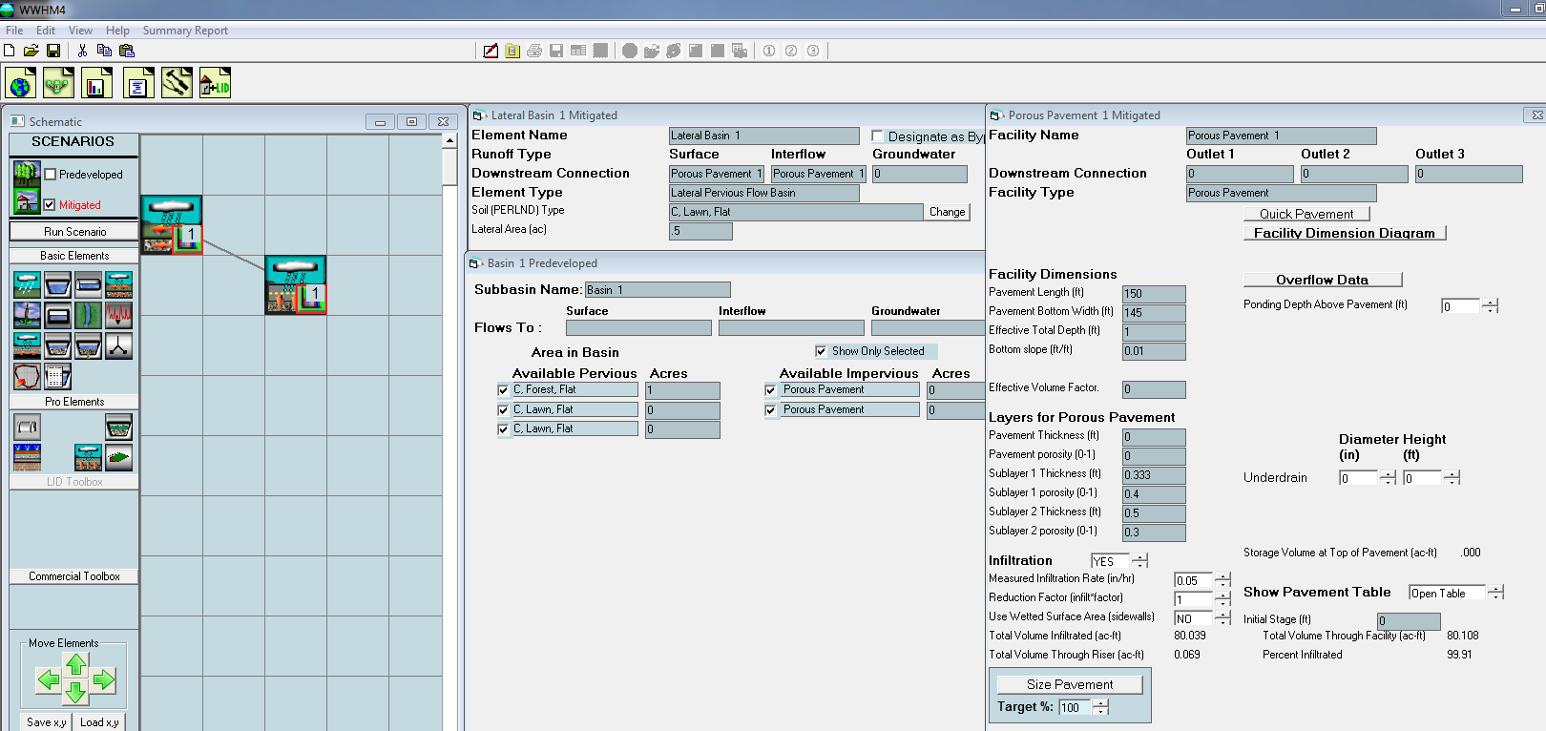

Infiltration Summary

Infiltration Rate Used and Why:
An infiltration rate of 0.05 inches per hour was used. The geotechnical report for this site indicates a minimum infiltration rate of 0.05 inches per hour.

Depth to Groundwater or Impermeable Layer:
Based on review of the site's geotechnical report, the seasonal high groundwater table is expected to be no higher than 10 feet below ground level. The bottom of the facility is 1.5 feet below ground level. The separation is 8.5 feet. This meets the criteria noted within the 2012 SWMMWW of greater than 5 feet of separation.

Site Characterization Criteria:
Could infiltration in this area have negative impacts? If so, please explain how these were accounted for in the overall design approach.
Lab results of the existing soils in the site's geotechnical report have CEC values above 5 meq per 100 grams and organic matter over 1% indicating that existing soils will treat the infiltrating water and protect the area from negative impacts. A sand layer was added to the design to further prevent higher negative impacts in this area.

South Tacoma Groundwater Protection District
Site 1 – South Tacoma Way and Site 2 – SERA are both located within the South Tacoma Groundwater Protection District. Does this site meet the requirements for infiltrating in these sensitive areas outlined in this policy? http://cms.cityoftacoma.org/surfacewater/swmm2008/0111.pdf
Yes

