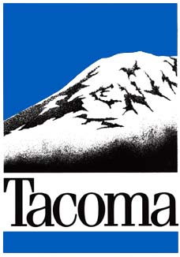 CALL TO COMMUNITY GROUPS

Tacoma Murals Project

Deadline: May 28, 2013
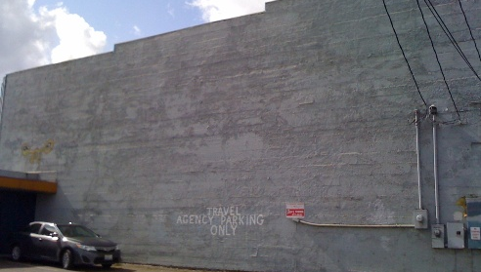
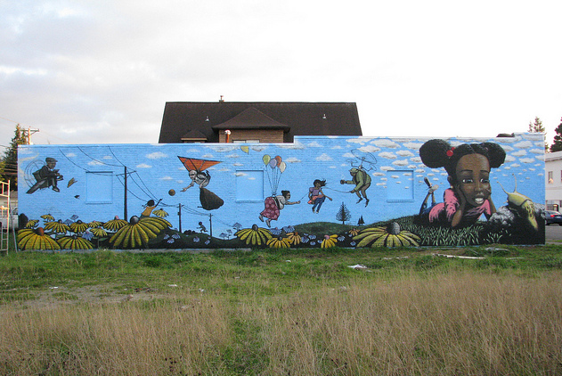
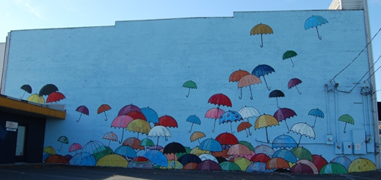
Before and after photos on left are of building at 220 Puyallup Ave. Lead artist: Chris Sharp. Artist team: Kate Cendejas, Yvette Simone, Janice Lee Warren.
Before and after photos on right are of building at 2143 MLK Jr. Way. Lead artist: Jeremy Gregory. Participating artists: Kate Cendejas, Larine Chung, Jena Marks, and Marlin Peterson. (Photos by Jeremy Gregory)

Opportunity
The City of Tacoma is seeking community groups who would like a mural painted at a specific site in their neighborhood to fight blight and combat vandalism. In addition to reclaiming spaces targeted by vandalism and illegal graffiti, murals can create a sense of place and identity for a neighborhood. Priority will be given to sites located in Community Based Services areas within Tacoma and/or sites without a good representation of public art.

The Tacoma Murals Project requires participation by community groups who are committed to their neighborhoods and agree to be active participants in the process.

The City of Tacoma will provide the selected community groups with:
- A funded mural, including supplies & artist compensation
- Technical assistance
- A trained mural artist/artist team to design and implement a mural
- Promotion and assistance

In return, it is understood that selected community groups will:
- Participate in the selection of an artist/artist team for their mural from a roster of pre-selected mural artists, to be provided by the City.
- Be open to the creative ideas of the artist/artist team. It is up to the artist/artist team to develop the design, based on their aesthetics as artists and based on the input from the community regarding theme or messages. We ask that the community group and property owner set aside any preconceived ideas of how their mural should look and be open to the creative process the artist/artist team will lead.
- Work cooperatively with the artist/artist team
- Be a resource to the artist/artist team for research, stories, content, etc… Note: artist/artist team will also approach members of the surrounding community to gather ideas.
- Assist in community coordination including community meetings and mural dedication.
- Implement and comply with appropriate agreements including:
  - Letter of Agreement between property owner, applicant, and City of Tacoma
  - Maintenance agreement (The community group and/or property owner will be responsible for maintenance of the mural. The City of Tacoma will have no obligation to maintain the mural; the mural will not be considered part of the City’s Municipal Art Collection.)
  - Property Easement
- Contribute in-kind services and/or materials as required to prepare the wall (e.g. removing overgrowth covering wall, pressure washing, priming)
NOTE: The artist/artist team will be responsible for final mural design and painting. Community groups will not be painting or designing the mural themselves. Murals cannot be advertisements or signage for any business, group, or organization.

Tacoma Murals Project Overview
The Tacoma Murals Project joins artists and communities through the collaborative process of mural-making to create powerful artworks that can transform public spaces, neighborhood identities, and individual lives.

Talented adult artists work with communities to design and implement high quality murals that reflect the stories and content researched from the community. Murals are designed to fight blight and combat vandalism in select neighborhoods in Tacoma.

The community groups are provided with funding to complete a mural, an artist/artist team to implement ideas, technical assistance, and general promotion of the project. In return, the selected community groups assist the artist/artist team through community coordination, input of stories and content, and maintenance of the mural after its completion.

Eligibility
- Applicant and proposed mural site must be located within the official city limits of Tacoma
- Priority will be given to sites located in Community Based Services (CBS) areas within Tacoma and/or sites located in areas without a good representation of public art. For information about CBS areas, go to www.cityoftacoma.org/CBS
- Applicant must exhibit community support and participation
- Applicant must have a specific mural site to propose and permission of property owner
- Proposed mural wall must be commercial or public property. Residential walls are not eligible. If wall is on publicly owned property or you are unsure of ownership, please contact Real Property Services at 253-591-5249 to verify ownership.

Selection Criteria
- Demonstrated need for at least one of the following:
  - Reduction of blight (i.e. beautify a wall that is neglected, ugly or plain)
  - Reduction of vandalism (i.e. reclaim a wall that is frequently hit by tagging or illegal graffiti)
  - Addition of public art in an area without a good representation of public art
- Community commitment demonstrated through the provision of support either through cash or in-kind services/product (e.g. volunteer hours, paint, services, space, etc…).
- Proof of community involvement
- Willingness to work with and be open to the creative ideas of the artist/artist team

NOTE: This is a competitive program and not every applicant will be selected. City of Tacoma may verify severity of vandalism against reported incidents at proposed mural site.

Timeline
May 28, 2013 Deadline for application submission
by June 7, 2013 Review of applications and selection of community groups
throughout summer 2013 Community coordination and mural implementation

Application and Submission
To apply:
- Fill out the online application at http://www.surveymonkey.com/s/TMP2013.

Or
If you do not have internet access, fill out the application on pages 6 & 7.
- Submit 2 - 5 digital photos of the proposed mural wall to tacoma.submissions@cityoftacoma.org. Photos should give a sense of the site and, if possible, document blight and/or instances of vandalism.
- Mail an original signed Letter of Agreement (form on pages 4 & 5) to:
City of Tacoma
Tacoma Murals Project
Attn: Naomi Strom-Avila
747 Market Street, #900
Tacoma, WA 98402

Help
For assistance, please call Naomi Strom-Avila at 253.591.5191 or email nstrom-avila@cityoftacoma.org.
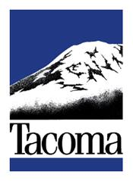
Tacoma Murals Project
Letter of Agreement

The purpose of the Tacoma Murals Project (“Project”) is to reclaim public and commercial spaces targeted by blight and vandalism, through the creation of beautiful, diverse and enduring community-based murals.

By signing this letter, _________________________ (“Property Owner”) warrants that
Name of property owner
he/she is the legal property owner and that he/she gives permission to the City of Tacoma (“City”) to utilize his/her property listed below for a mural painting through the Project.

___________________________________________________________________

Property address

___________________________________________________________________

Description of wall location (i.e.: North wall of building facing 38th Street)

_________________________ (“Applicant”) has applied to the City to participate in the Project.
Name of applicant community group

If selected, the City will provide the Applicant with:
- A funded mural, including supplies & artist compensation
- Technical assistance
- A trained mural artist/artist team to design and implement a mural
- Promotion and assistance

If selected, the Applicant will actively participate in the mural process by:
- Participating in the selection of an artist/artist team for their mural from a roster of pre-selected mural artists, to be provided by the City.
- Being open to the creative ideas of the artist/artist team. It is up to the artist/artist team to develop the design, based on their aesthetics as artists and based on the input from the community regarding theme or messages. We ask that the Applicant set aside any preconceived ideas of how their mural should look and be open to the creative process the artist/artist team will lead.
- Working cooperatively with the artist/artist team
- Providing general input about what messages or themes the community would like represented in a mural.
- Assisting in community coordination including community meetings and mural dedication
- Implementing and complying with appropriate agreements including:
  - This Letter of Agreement between property owner, applicant, and City of Tacoma
  - Maintenance agreement (The Applicant and/or Property Owner will be responsible for maintenance of the mural. The City will have no obligation to maintain the mural; the mural will not be considered part of the City’s Municipal Art Collection.)
  - Property Easement
- Contributing in-kind services and/or materials as required to prepare the wall (e.g. removing overgrowth covering wall, pressure washing, priming)

If selected, the Property Owner will actively participate in the mural process by:
- Being open to the creative ideas of the artist/artist team. It is up to the artist/artist team to develop the design, based on their aesthetics as artists and based on the input from the community regarding theme or messages. We ask that the Property Owner set aside any preconceived ideas of how their mural should look and be open to the creative process the artist/artist team will lead.
- Cooperating and collaborating with the Applicant and the artist/artist team in developing a design that reflects some of the themes and/or messages provided by community participants.
- Providing reasonable access to the portion of your property listed above to the Applicant and artist/artist team for the purpose of designing and painting the mural
- Allowing the City to utilize photos of the building/business for promotion of the Program
- Implementing and complying with appropriate agreements including:
  - This Letter of Agreement between property owner, applicant, and City of Tacoma
  - Maintenance agreement (The Applicant and/or Property Owner will be responsible for maintenance of the mural. The City will have no obligation to maintain the mural; the mural will not be considered part of the City’s Municipal Art Collection.)
  - Property Easement

__________________________________________ agrees to take responsibility for the maintenance of the

Applicant and/or Property Owner
mural after completion by artist/artist team. The City will have no obligation to maintain the mural following the completion thereof.

The City will select Applicants to participate in the Project by June 7, 2013. Community coordination and mural implementation will be ongoing throughout summer 2013 with mural completion by fall 2013.

By signing below, Property Owner, Applicant and the City accept the terms of this agreement.

Approved by:
Property Owner
_______________________________
Signature
_______________________________

Name
_______________________________

Date
City of Tacoma Representative
_______________________________
Signature

Amy McBride

_______________________________

Date

Applicant
_______________________________
Signature

_______________________________

Name

_______________________________

Date

Tacoma Murals Project – Community Mural Application

Name of Applicant Group

Contact Person

Contact Person’s Full Address

Contact Person’s Phone

Contact Person’s E-mail

Describe your group. How many people are there in the group? What unifies them?

Describe your community. Use this space to show proof of community involvement in this project. Who is involved with and/or aware of this project?

Why do you want to have a mural painted in your neighborhood? Use this space to describe the need (e.g. blight, vandalism, etc…).

Where would you like to see a mural painted? Include address/cross streets and any other pertinent information about the site or surrounding area.

What is the size of the proposed wall (height x width)?

What is the surface material (e.g. brick, wood, concrete, metal…) and condition of the proposed wall?

Do you have permission from the property owner to have a mural painted at this site?

Who will be responsible for maintaining the completed mural? Note: this should be the property owner, the community group, or a combination of the two.

Would you or someone in your group be able to participate in coordinating the artists’ work with your community this spring/summer?

If there are language barriers, would you or someone in your group be able to assist with translation?

What cash or in-kind services will your group provide to help support this project?

